Assignment 3  
Group Sierpinski S-23  
  
You can find the queries in .sql format in the same folder as this document, here are screenshots of them running correctly, and you can test them on our db as well.  
  
ReportQ.sql: Join  
Find all the reports that are related to the specific task  
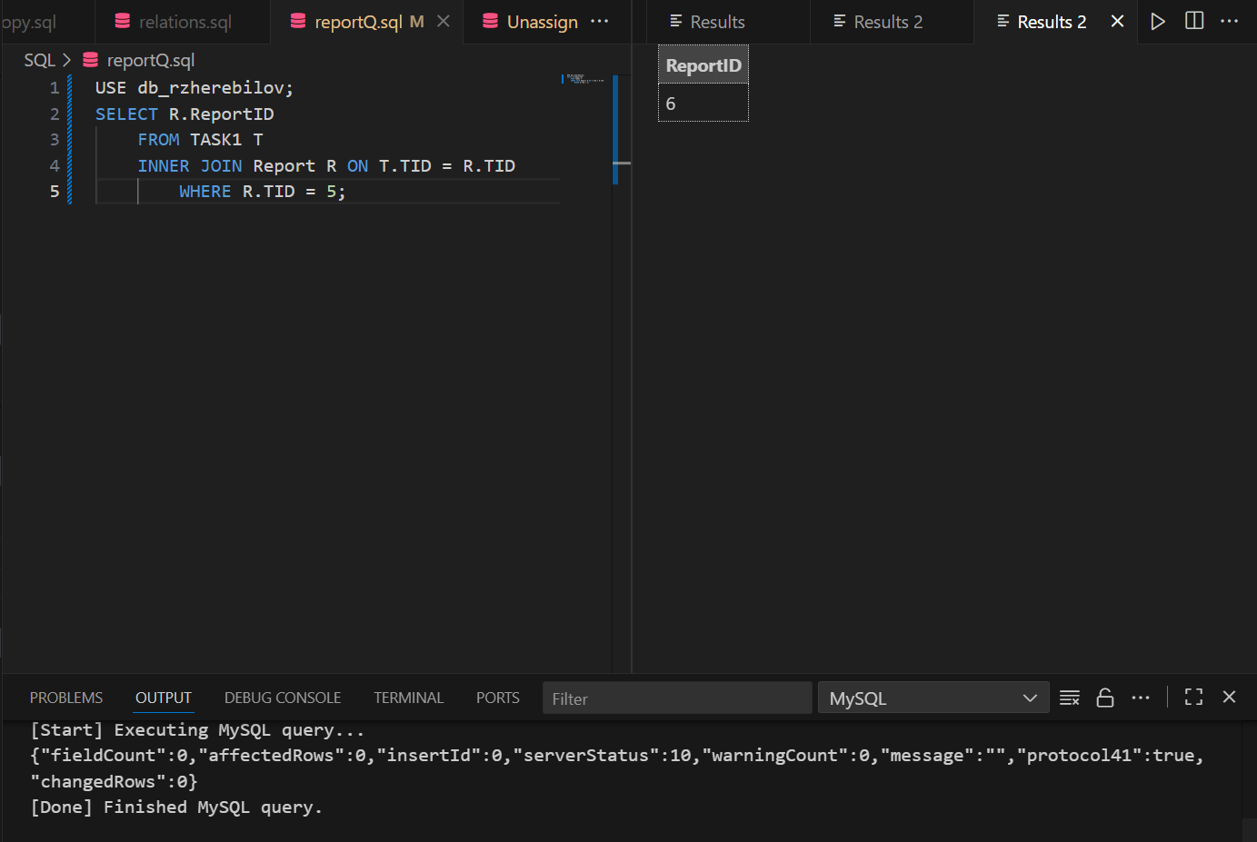  
UnassignedGQ.sql: Join, Group by  
Find all of the tasks which do not have agents assigned to them (unnassigned status)  
  
  
  
  
  
  
  
  
  
  
  
  
  
  
  
  
  
  
QuartersNotFull.sql: join, clause, group, everything  
List all the quarters where the number of people assigned does not exceed the room’s capacity  
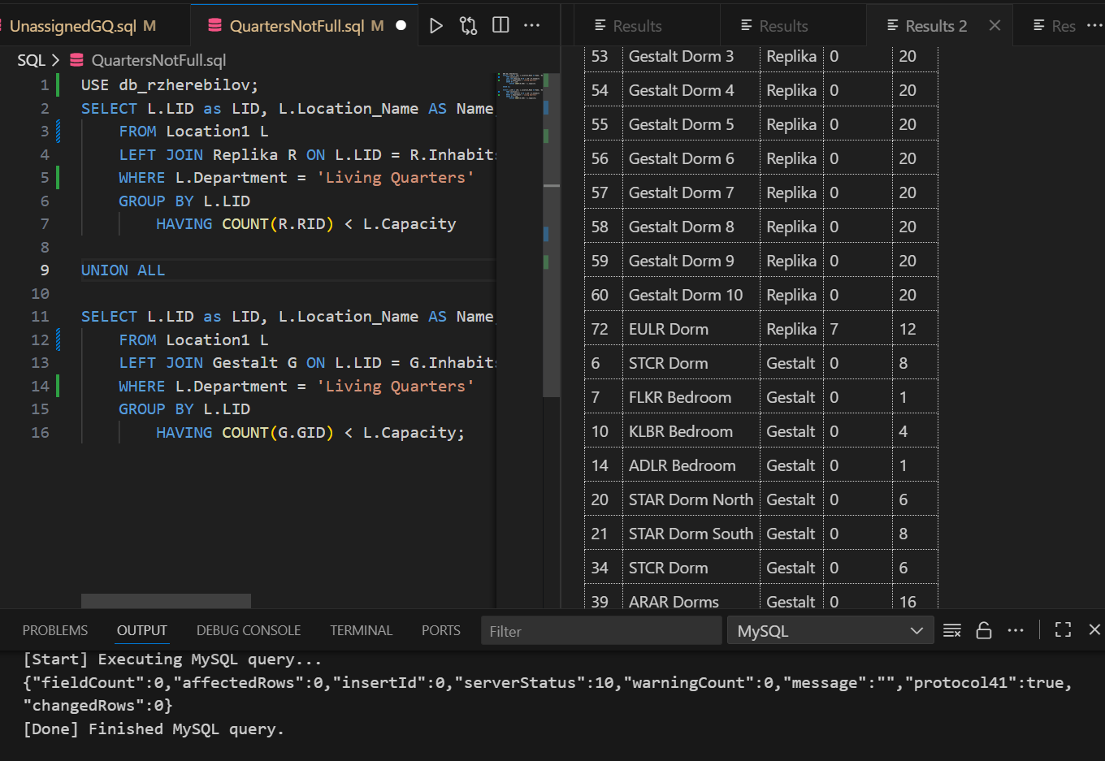  
  
InhabitsQ.sql: Join, order, union  
Lists all of the inhabitants that live in the dorm with applied search prompt   
  
  
  
  
  
  
  
  
  
  
  
  
  
  
  
  
  
  
Clearance2Q.sql  
List all of the available agents with enough clearance to meet the requirements of the clearance for the specific task (in this case RID 2) is the unassigned admin with highest clearance  
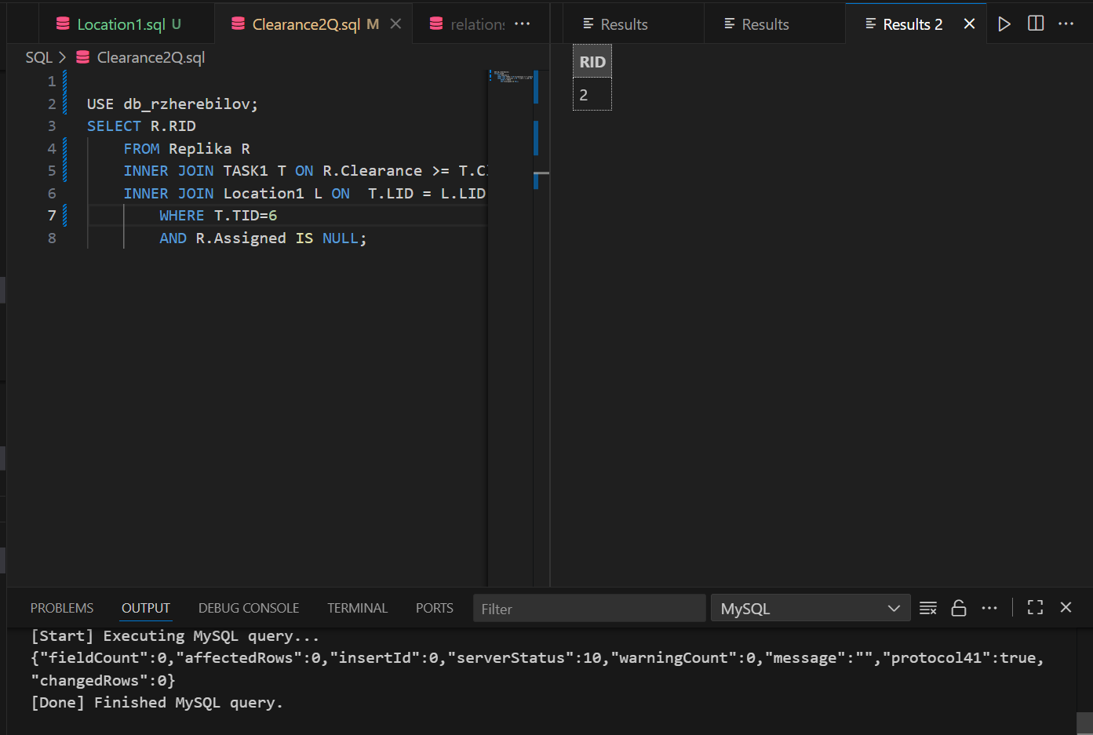  
ClearancaQMAX.sql  
List all of the replikas with the highest level of clearance  
